Terraform VPC Integration account
terraform-aws-xebia-vpc@v0.8.0

Requirements
1. Transit Gateway ID
2. CIDR Block
3. public subnets
4. private subnets

This module creates a VPC alongside a variety of related resources, including:

1. IAM Policy for vpc flow log cloudwatch
{
"Statement": [
{
"Action": [
"logs:PutLogEvents",
"logs:DescribeLogStreams",
"logs:DescribeLogGroups",
"logs:CreateLogStream"
],
"Effect": "Allow",
"Resource": "*",
"Sid": "AWSVPCFlowLogsPushToCloudWatch"
}
],
"Version": "2012-10-17"
}

2. IAM Role for vpc flow log cloudwatch
3. Elastic IP and Nat gateway
4. Cloud Watch Log group
5. Internet Gateway
6. Security group
7. public and private subnets
8. route table for the subnets
9. Transit Gateway VPC attachment
10. VPC Endpoints
- ssm: The endpoint for the Systems Manager service.
- ec2messages: Systems Manager uses this endpoint to make calls from SSM Agent to the systems Manager service.
- ec2: If you're using Systems Manager to create VSS-enabled snapshots, you need to ensure that you have an endpoint to the EC2 service. Without the EC2 endpoint defined, a call to enumerate attached EBS volumes fails, which causes the Systems Manager command to fail.
- ssmmessages: This endpoint is required only if you are connecting to your instances through a secure data channel using Session Manager.

Key Variables: -
name - Name of the VPC (ex: - integration-dev-vpc, data-analytics-dev-vpc)
project - Name of the project this VPC is meant to house (ex: - Integration, data-analytics)
environment - Name of the environment this VPC is targeting (ex: - dev, prod)
region - Region of the VPC (default: ap-southeast-1)
cidr_block - CIDR block for the VPC
public_subnet_cidr_blocks - List of public subnets CIDR blocks
private_subnet_cidr_blocks - List of private subnets CIDR blocks
availability_zones - List of availability zones (default: ["ap-southeast-1a", "ap-southeast-1b"])
tags - Extra tags to attach to the VPC resources (ex: {"Environment": "dev", "ManagedBy": "terraform", "Owner": "xebia", "ProjectName": "integration"})
The below steps to be followed to create a vpc using terraform scripts in GitHub Actions.
Steps: -
Step 1: - Clone the integration-account repo and create a new folder (ex: - 01-vpc or 24-vpc-data-analytics) and copy the contents of any existing vpc folder

Step 2: - Make the following changes to the "terraform.tfvars" file
1. use the same Transit Gateway ID present in the aws account unless requested to create a new one
2. change the CIDR, Public and Private subnets block with the given values
3. under "ingress_rules_vpc_endpoints_sg" the cidr_block value should be same as CIDR

Step 3: - Make the following changes to the "Backend.tf"
1. change the value of the attribute "key"
ex: - "key" = "dev/01-vpc/terraform.tfstate" -> "dev/<new-folder-name>/terraform.tfstate"

Step 4: - Push the code to GitHub and go to Actions
- click the Deployer workflow
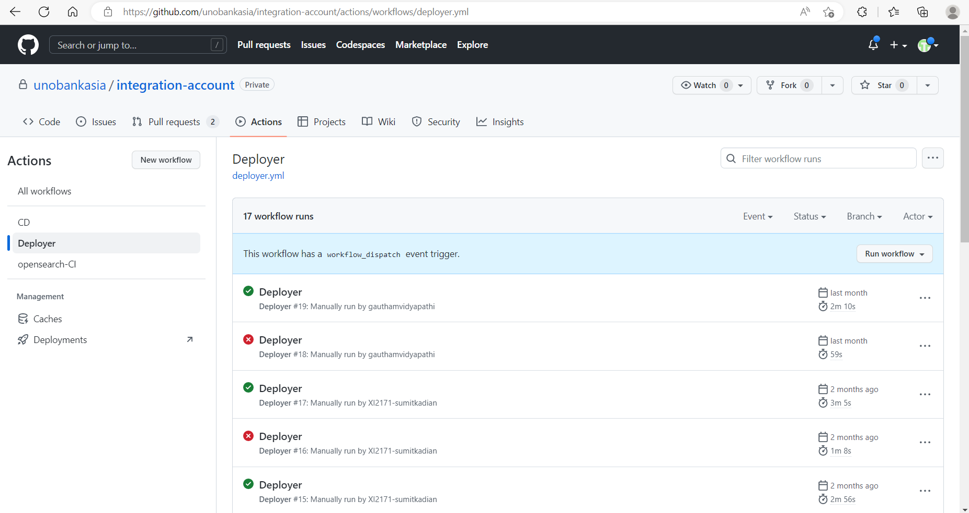

2. Expand Run workflow
- select branch, Env, service name i.e., the folder name created
- select apply in action to perform and click Run workflow
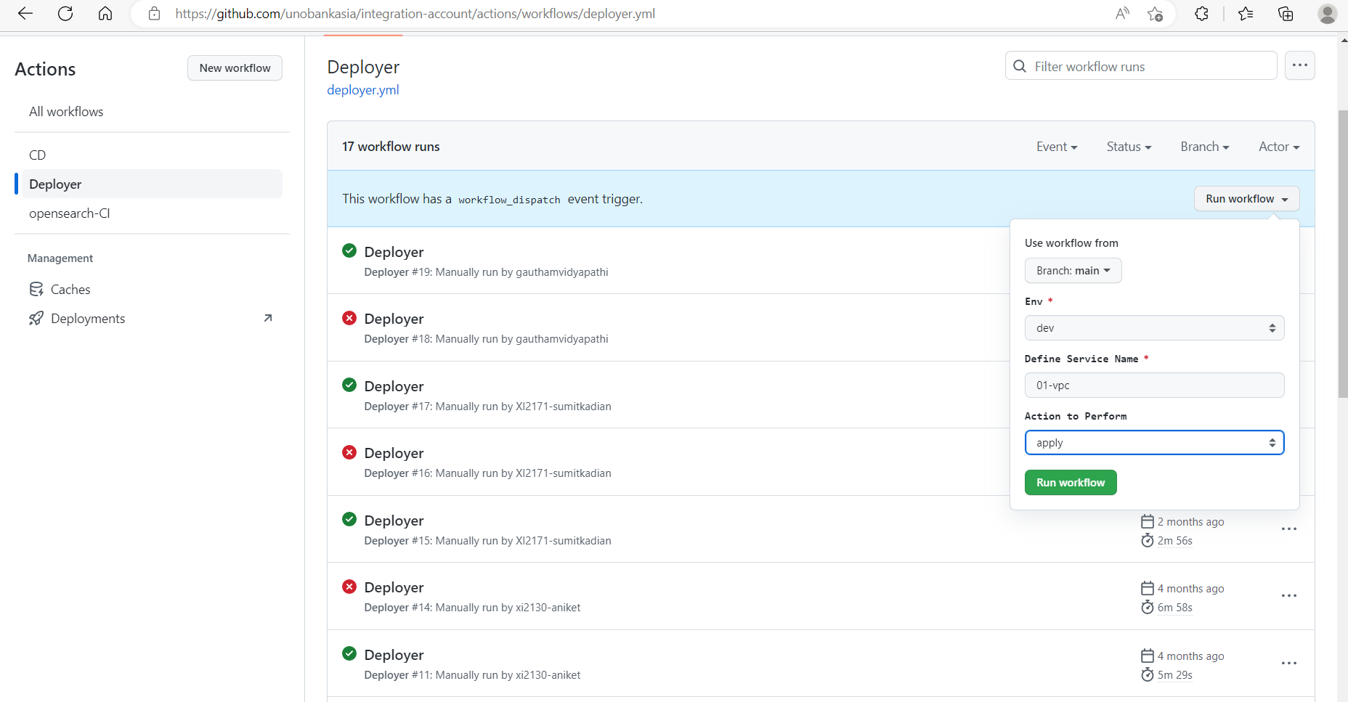

The image below represents a successful execution of the workflow
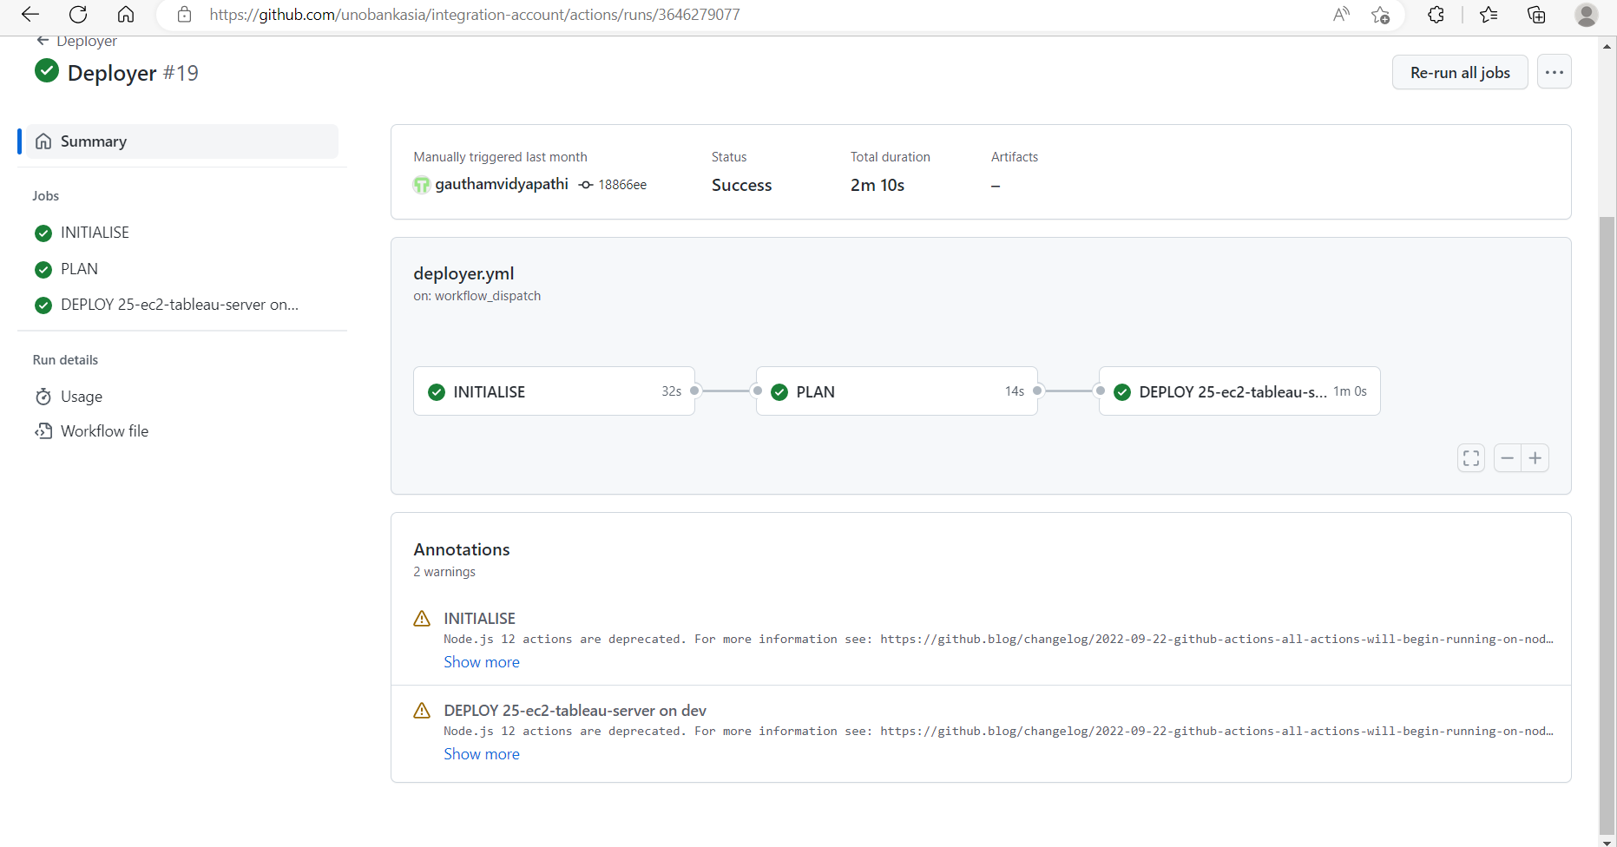
The below image represents an unsuccessful execution of the workflow
